10 Minutos com Maven, TestNG e Selenium
- Criar um novo projeto Maven no Eclipse:
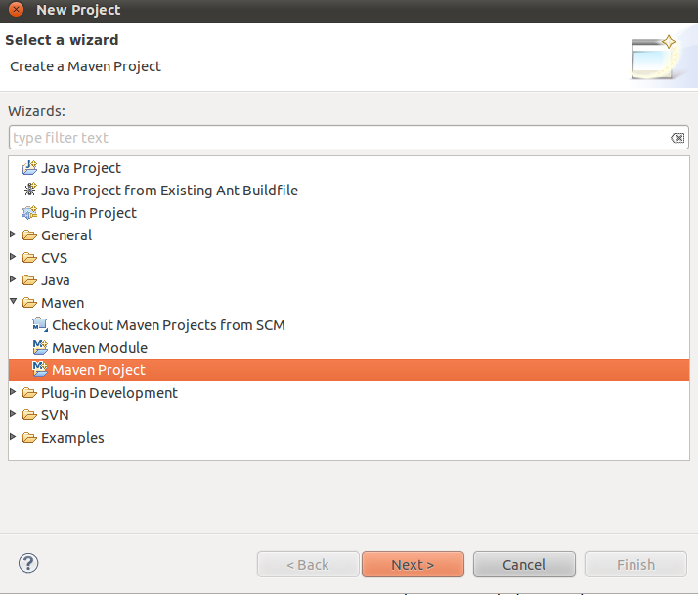
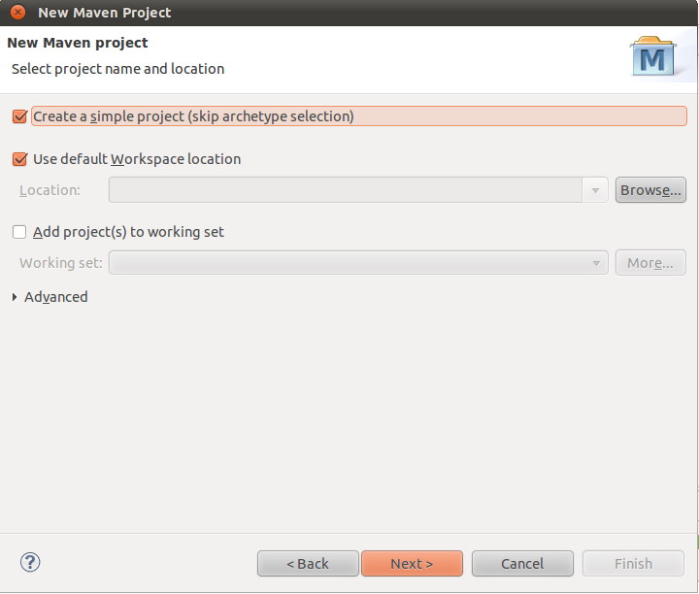
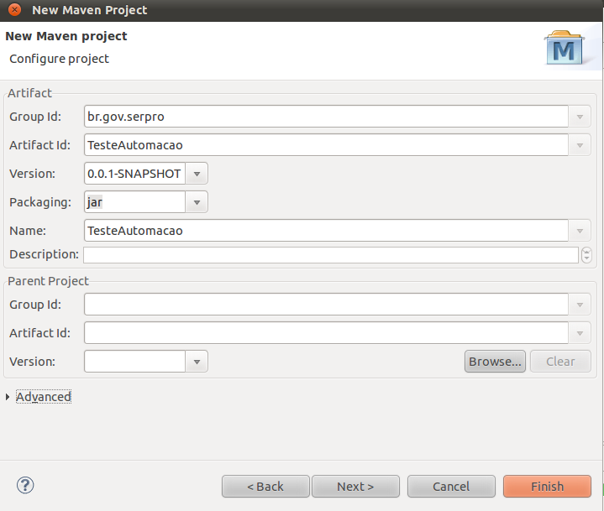
- Editar pom.xml para adicionar as dependencias do projeto logo abaixo da tag <name> do projeto
<dependencies>
<dependency>
<groupId>org.testng</groupId>
<artifactId>testng</artifactId>
<version>5.14.1</version>
<scope>test</scope>
</dependency>
<dependency>
<groupId>org.seleniumhq.selenium</groupId>
<artifactId>selenium</artifactId>
<version>2.0b1</version>
</dependency>
</dependencies>

Automaticamente o maven baixará todos as dependências e colocará no path do projeto.
- Criar uma classe para testar a configuração:
import org.openqa.selenium.By;
import org.openqa.selenium.WebDriver;
import org.openqa.selenium.WebElement;
import org.openqa.selenium.firefox.FirefoxDriver;
import org.testng.annotations.Test;
public class FirefoxDriverExample {
@Test
public void testIt() {
// Create a new instance of the firefox driver
WebDriver driver = new FirefoxDriver();
// And now use this to visit Google
driver.get("http://www.google.com");
// Find the text input element by its name
WebElement element = driver.findElement(By.name("q"));
// Enter something to search for
element.sendKeys("Cheese!");
// Now submit the form. WebDriver will find the form for us from the element
element.submit();
// Check the title of the page
System.out.println("Page title is: " + driver.getTitle());
driver.close();
}
}

- Rodar o teste usando o TestNG.

